Test Case Screenshots

**Karina-**

Valid Login By User:

Invalid Login By User:

Valid Login By Tech:

Invalid Login By Tech:

**James-**

Creation of Ticket By User:

Creation of Ticket By Tech:

Invalid/Missing inputs on ticket creation:

No description

Missing subject:

**Grant-**

All tickets show for Tech:

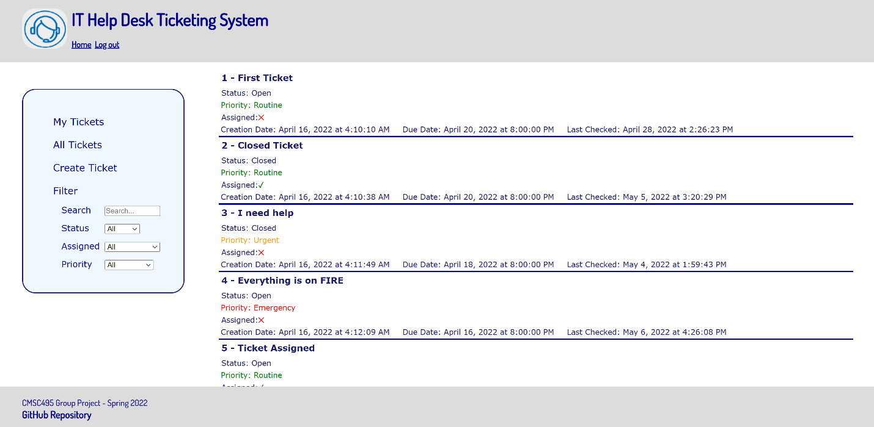

Only user tickets show for User:

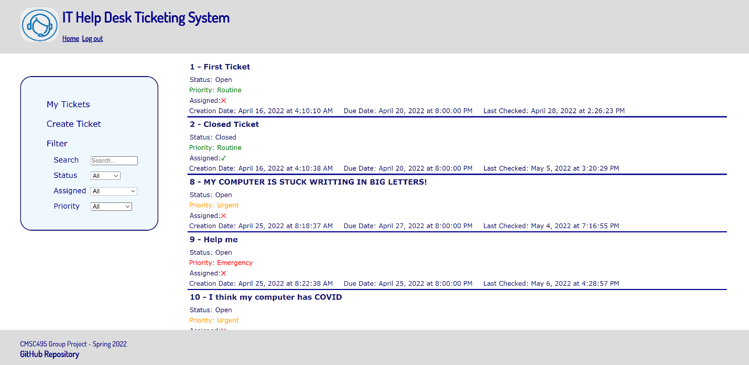

Status filter:

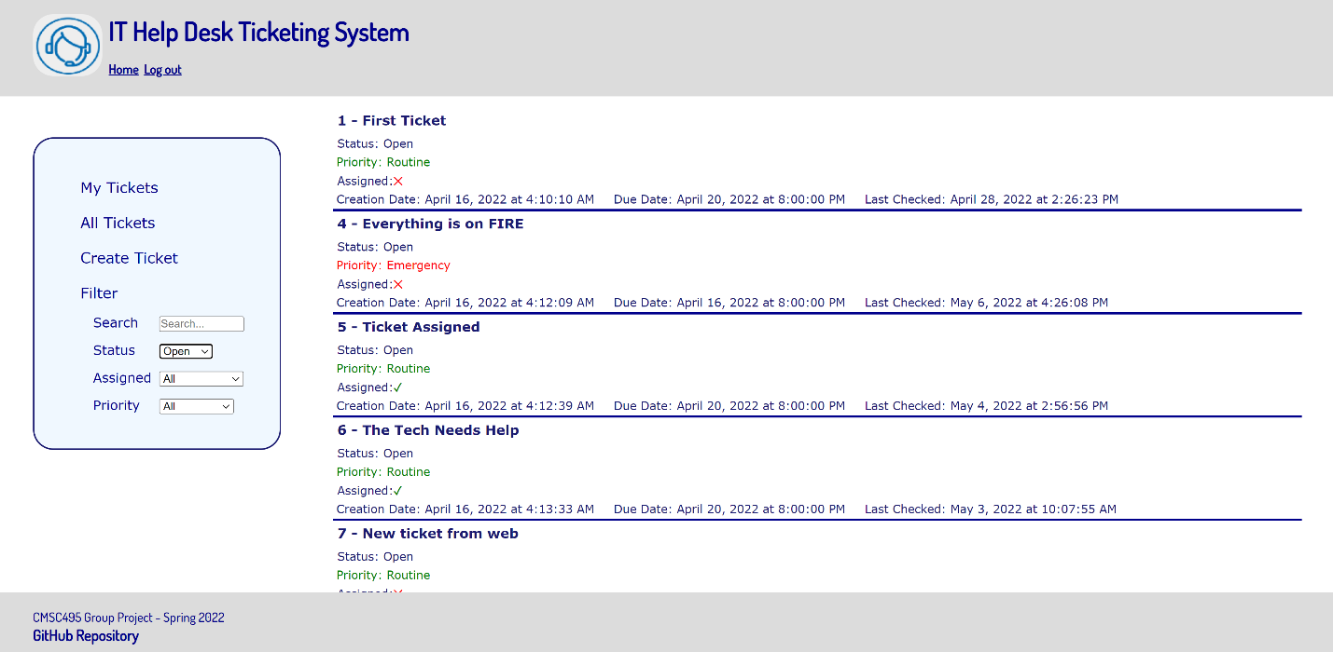

Assigned filter:

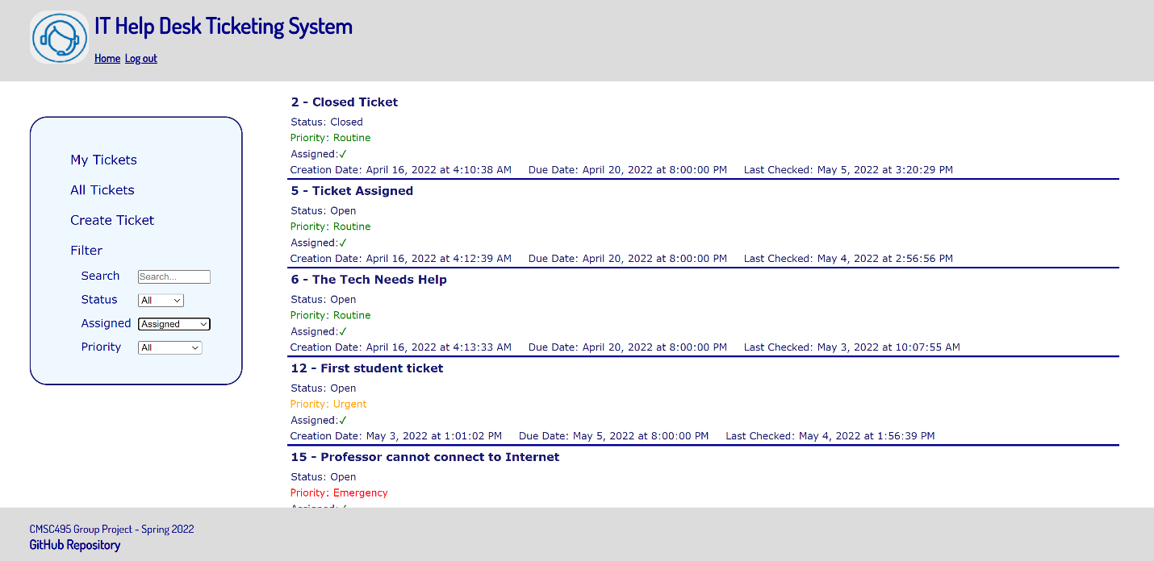

Priority filter:

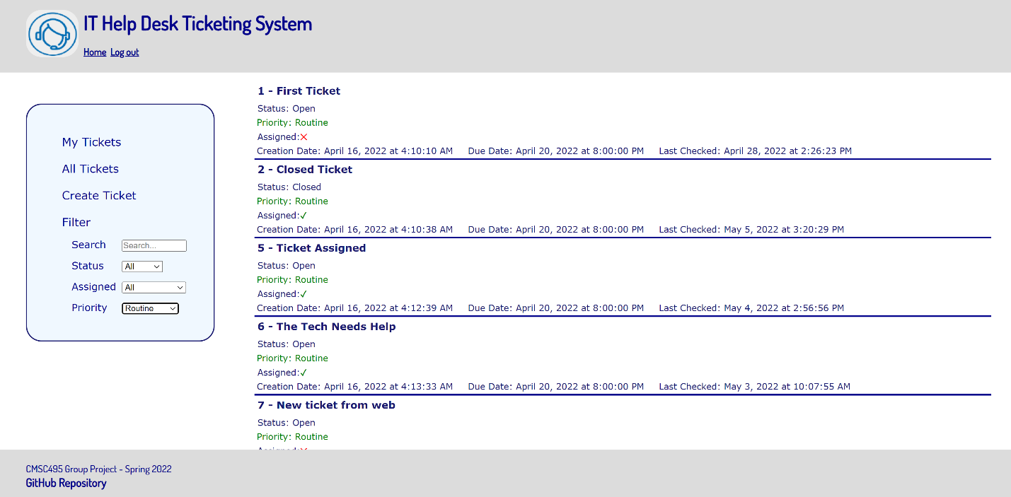

My Tickets functioning:

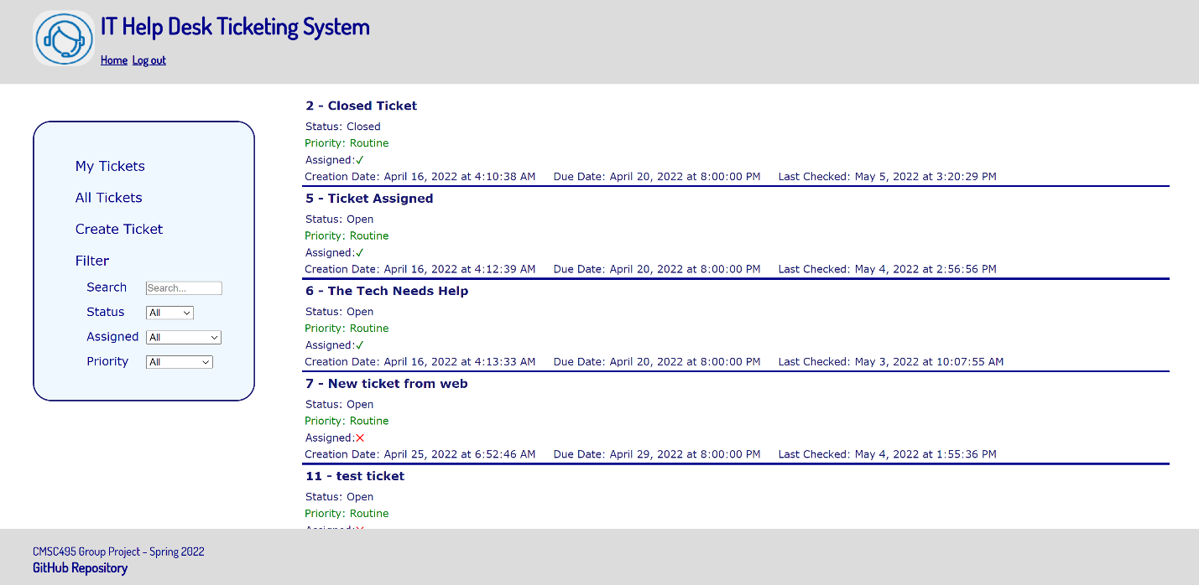

All tickets functioning:

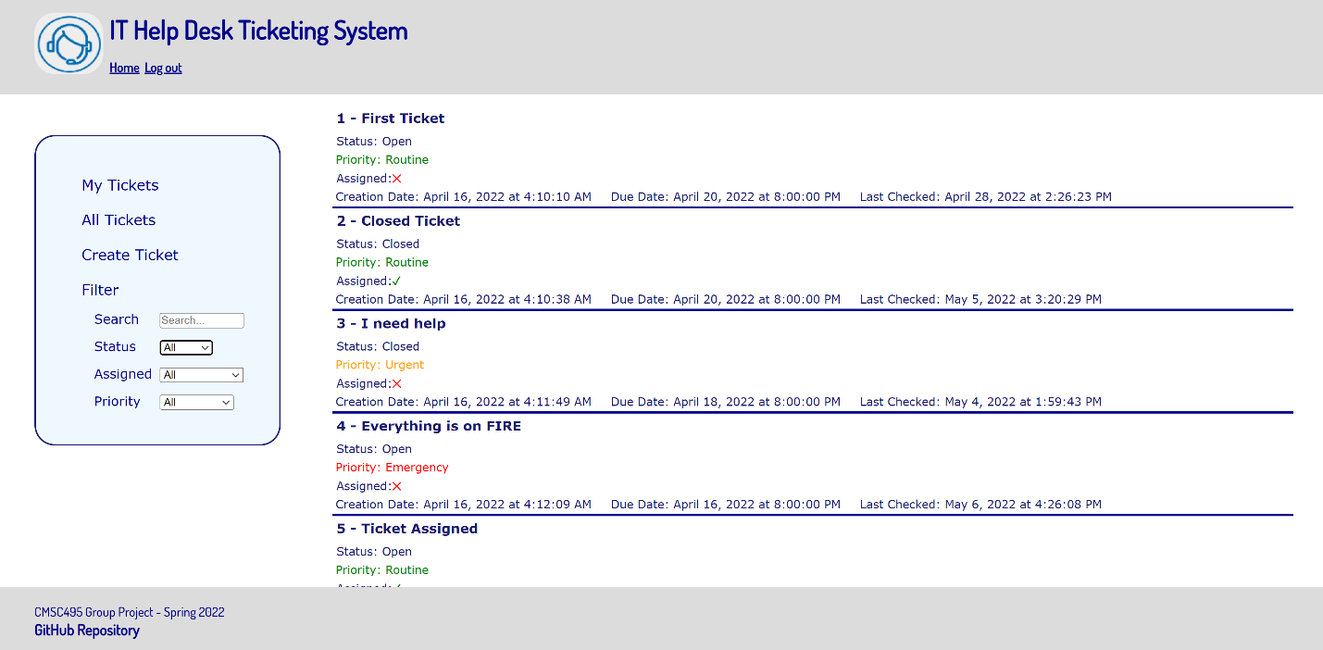

Search functioning:

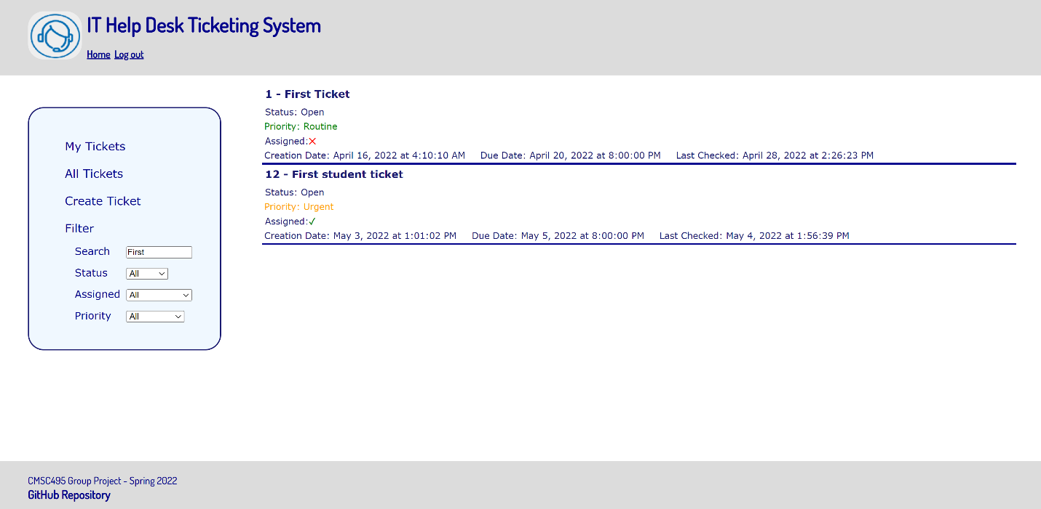

**Jared-**

Ticket information showing:

Add comment:

Invalid/Missing inputs on comment section:

Closing ticket:

Re-opening ticket:

Assigning ticket: